1. DUPLICATE COUNT

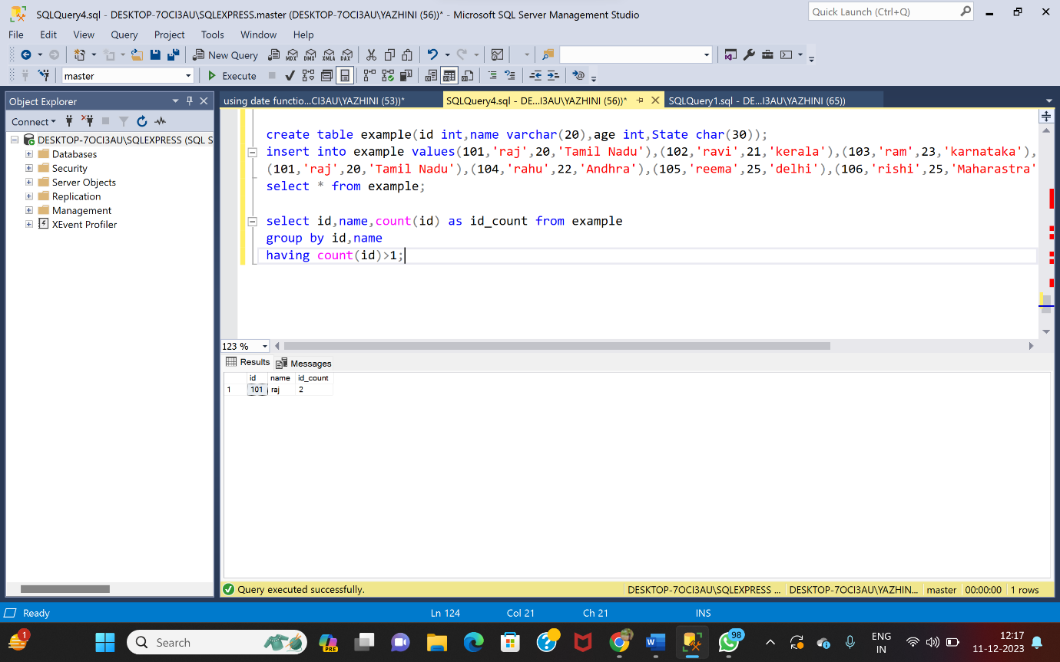

2)DELETING DUPLICATE

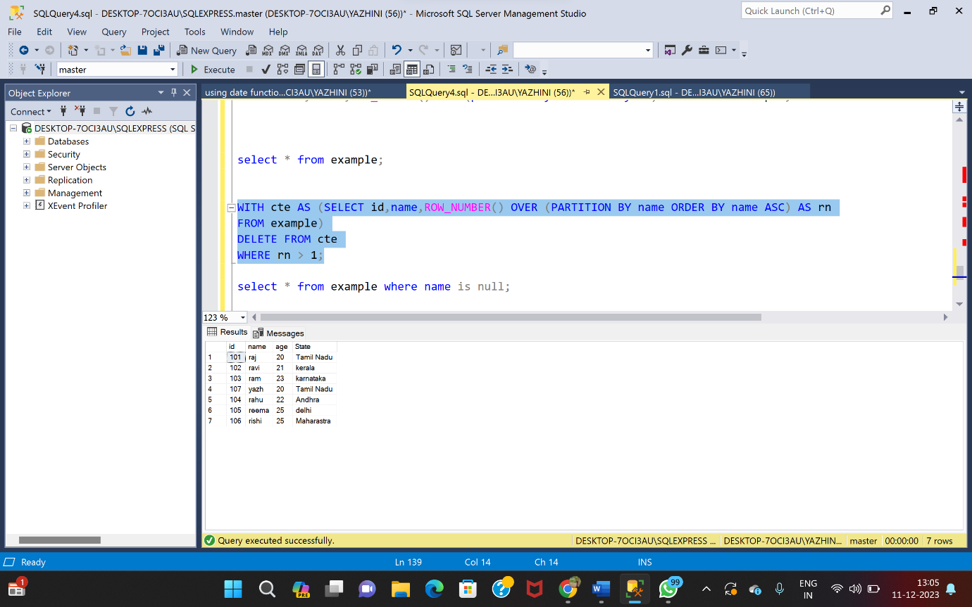

3)SELECTING NULL VALUES

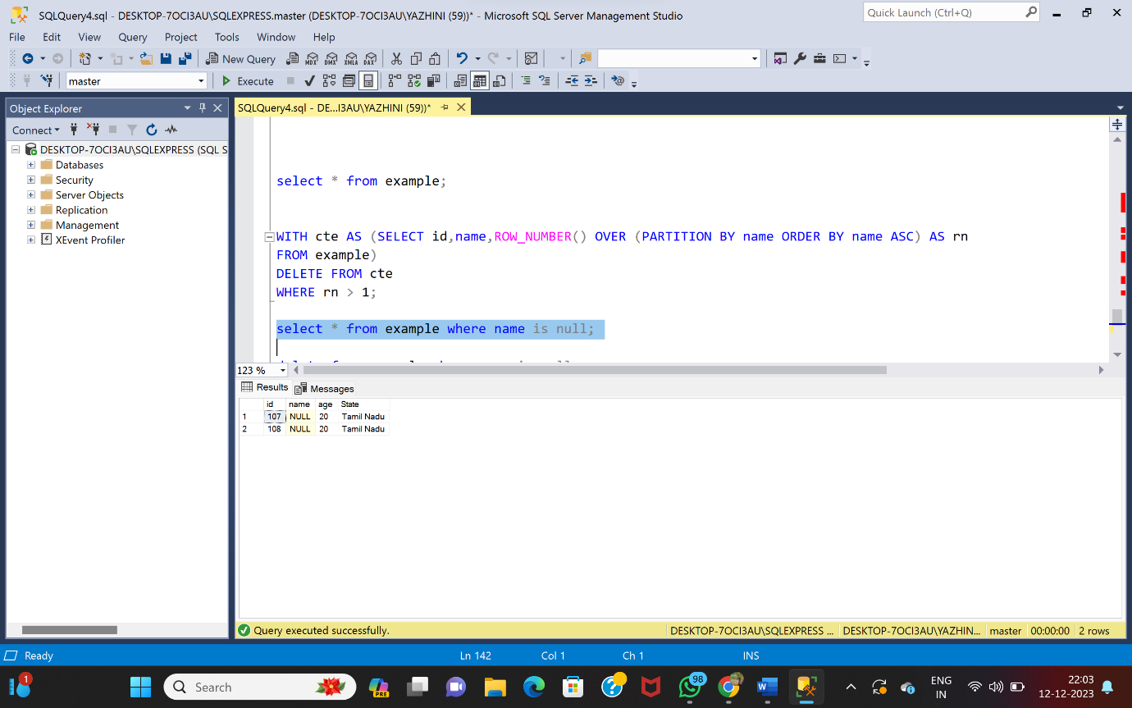

4)UPDATING NULL VALUES

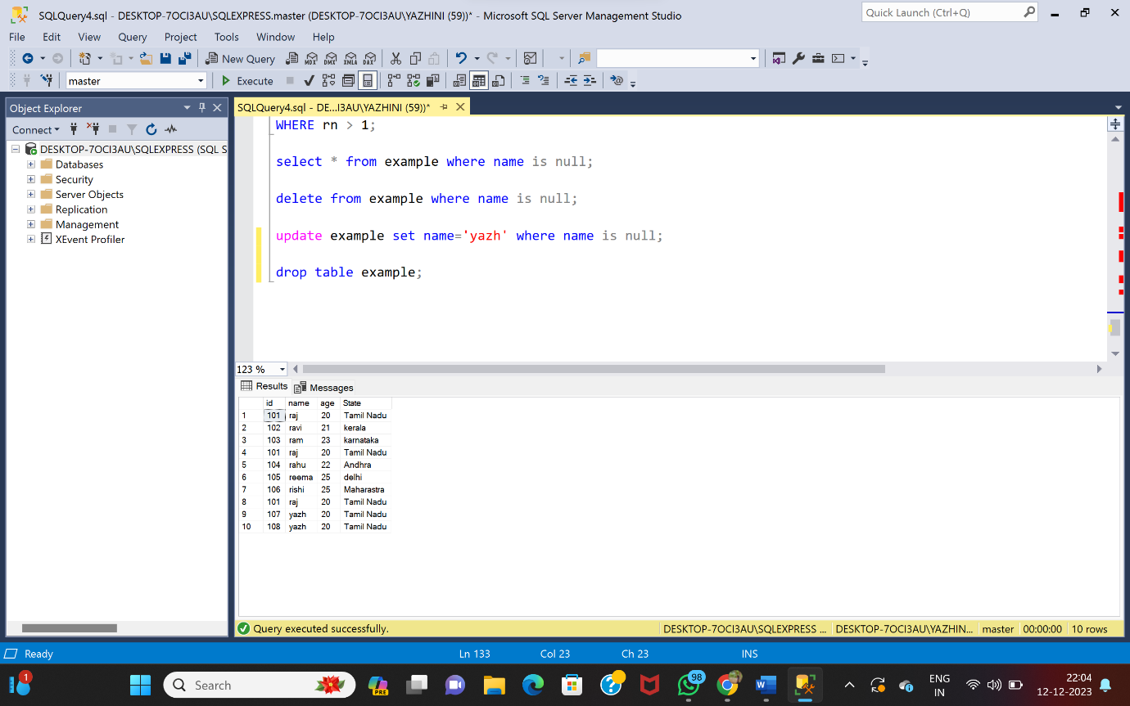

5)DELETING NULL VALUES

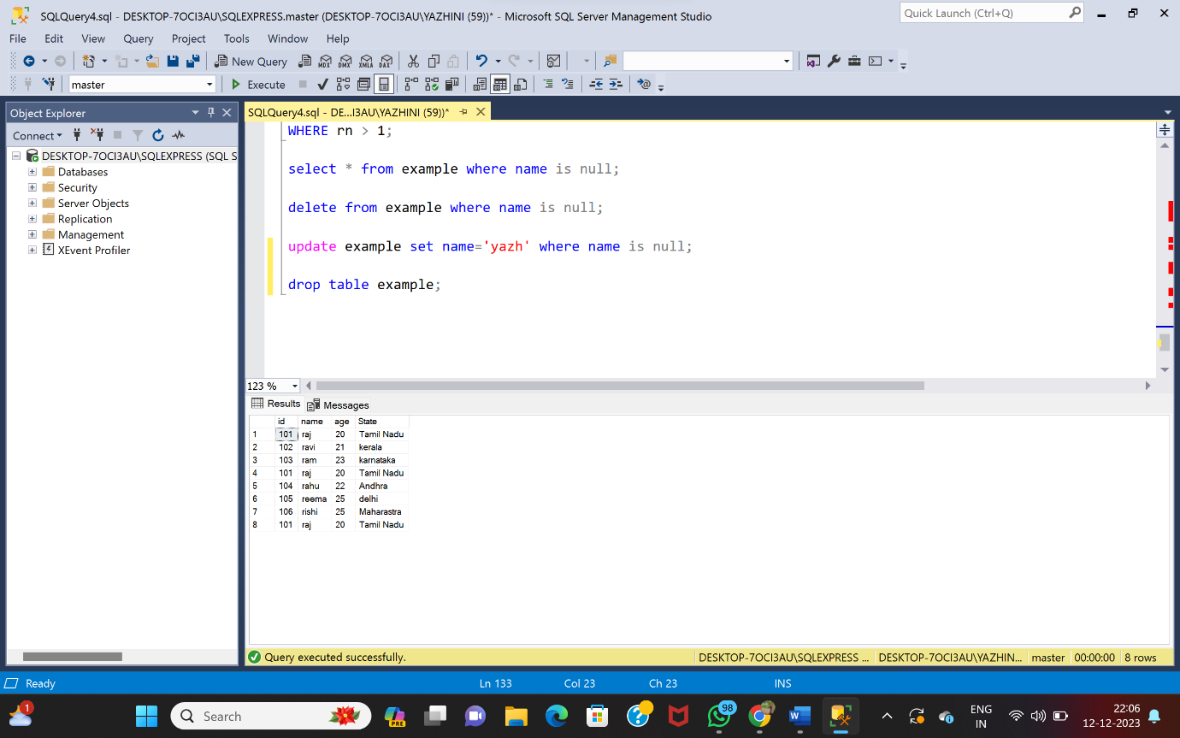

6)PARTITION BY

